The Out-of-Body Travel Foundation’s
Hymnal!
By Marilynn Hughes
The Out-of-Body Travel Foundation!
www.outofbodytravel.org
Music by the author of scenes from the Out-of-Body Travel Books of Marilynn Hughes, heard during her own Out-of-Body Experiences.
[You may purchase CD Soundtracks to this Hymnal]
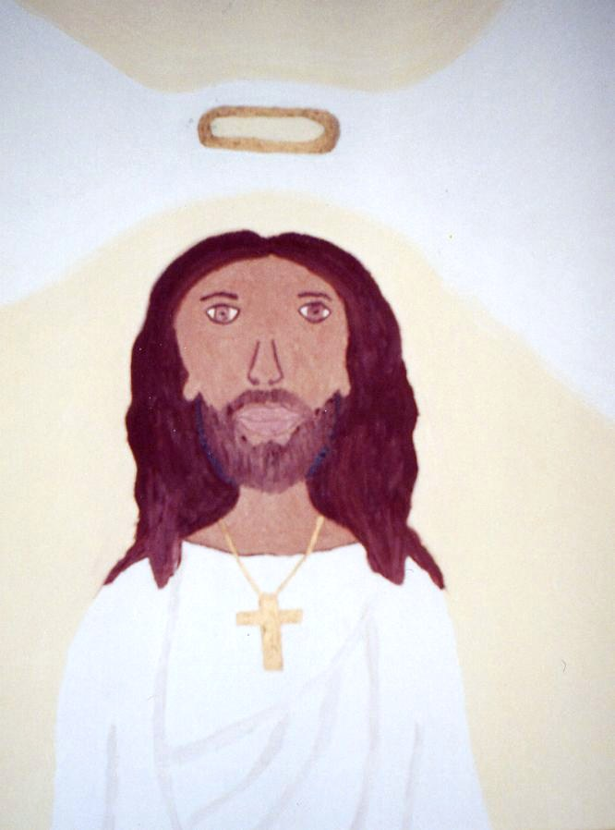
Copyright © 2003, Marilynn Hughes (Writing, Music, Artwork and Music Performance)
All rights reserved, including the right to reproduce this work or portions thereof in any form whatsoever without permission in writing from the publisher and author, except for brief passages in connection with a review.
All credits for quotations are included in the Bibliography.
For information, write to:
The Out-of-Body Travel Foundation!
www.outofbodytravel.org
If this book is unavailable from your local bookseller, it may be obtained directly from the Out-of-Body Travel Foundation by going to www.outofbodytravel.org.
Having worked primarily in radio broadcasting, Marilynn Hughes spent several years as a news reporter, producer and anchor before deciding to stay at home with her three children. She's experienced, researched, written, and taught about out-of-body travel since 1987.

Books by Marilynn Hughes
Listed in the Back of the Book
TABLE OF CONTENTS:
The Mysteries of the Redemption: A Treatise on Out-of-Body Travel and Mysticism
By Marilynn Hughes
Soundtrack

All Songs written and performed by Marilynn Hughes, and engineered by Bill Morrison at CosmixSound, Durango, Colorado. Except for CD 1, cut 1, I Feel the Change, and CD 3, cut 23, He Was There. Don Richmond, Howling Dog Recording Studio, Alamosa, Colorado – Production, Engineering, Instrumental Arrangements and Performance.

Index of Hymns

Compact Disc 1 (of 5)
1.) I Feel the Change (Produced Version), 7
2.) Eternal Pathways, 9
3.) The Notable One, 12
4.) Sky, 14
5.) I am the Grandfather, 15
6.) You're Not Alone, 16
7.) Ancient Thought, 19
8.) Stallion of the Lake, 21
9.) The Seashell, 22
10.) Gridimaria, 24
11.) Gypsy, 25
12.) In Your Name, 27
13.) Chant of Nor, 29
14.) Spirit Crucified on Earth, 30
15.) The Holy Grail, 32
16.) Once in a Lifetime, 35
17.) Build a Bridge, 37
18.) Before the Day you Die, 39
19.) The Whole of Life, 40
20.) Listen to the Wind, 43
21.) Grand Awakening, 45
22.) White Wolf, 48
23.) To Retrieve a Golden Angel, 50
24.) Gotta Wake Up, 52
25.) For the Ascension, 54

Compact Disc 2 (of 5)
1.) Change the World, 56
2.) Thunder Traveling to Loftier Heights, 59
3.) Apology, 61
4.) I'm a Bunny, 64
5.) Wage Peace Inside, 65
6.) The Ghost of Lonely Children, 67
7.) Storms of the Red Hawk, 69
8.) The Song of Life, 70
9.) Look Away, Window Heart, 72
10.) Angel Woman, 74
11.) Hallelujah to the Lord, 76
12.) Heal Thyself, 78
13.) Across the River, 79
14.) I Feel the Change, 81
15.) And the Light Came Tumbling on in, 83
16.) Pray for the Souls We've Lost to Darkness From the Light, 85
17.) Mother Earth, 87
18.) Holy Love, 90
19.) Exodus, 92
20.) Time, 94
21.) It Was All Over You, 96
22.) Chant, 99
23.) When God Will Step In, 100
24.) I Am, 103
25.) More of You, 106
26.) Mary, Jesus, 108

Compact Disc 3 (of 5)
1.) Go, and Sin no More, 110
2.) Voice of the Still One, 112
3.) Who am I to Say, 114
4.) Maybe My Saviour's Gonna Be With Me Tonight, 116
5.) Hey La, 119
6.) Life's Short Little Dance, 121
7.) The Patriarchal Swoon, 124
8.) One and Only Mary, 125
9.) Starlight, 127
10.) Westwind, 129
11.) I Wish I Were an Angel, 132
12.) I Love the Lord, 135
13.) Holy Mary, 137
14.) Sing to Jesus, 138
15.) Hallelujah, 140
16.) The Mystical Jesus, 141
17.) Ave Maria, 143
18.) Peace on Earth Unfolding, 144
19.) Holy Mother of God, 146
20.) Wisdom of the Guru, 148
21.) Get Down on my Knees, 150
22.) I Want to Be Like Jesus, 153
23.) He Was There (Produced Song), 155
(Dedicated to the memory of Doug,
my friend who died in a car accident; in honor of the woman he left behind,
and the child she bore after his death.)

Compact Disc 4 (of 5)
1.) Operator of the Sky, 158
2.) Modern Day Slaves, 160
3.) What Your Eyes Will Never Show, 162
4.) You Could Be a Fantasy (For Andy, my husband), 165
5.) I Believe in Love, 167
6.) Dream With Me, 169
7.) Country Road, 171
8.) Angel in Waiting, 174
9.) Breeze in the Willow, 176
10.) Green Peace, 178
11.) Near Death, 180
12.) Adaleda of God, 182
13.) Life Above Me, 184
14.) High Road, 186
15.) Visiontown, 189
16.) Lift Up Your Hearts, 190
17.) Born Beneath the Soul, 192
18.) Can You Feel it in Your Soul - (Given by John Denver), 193

Compact Disc 5 (of 5)
1.) Dreamquest - (Given by Jim Morrison of the Doors), 195
2.) I Remember His Name - (For Doug, my friend who died in a car accident at 21), 197
3.) Haunted by a Memory - (For Karleen, my dear friend who shared her after-death journey in Galactica), 200
4.) Orphan in Your Dream – (For Karleen), 202
5.) Ancestral Image - (For Arta and Helen Uzebacheff), 204
6.) Faces & Souls - (For all my ancestors), 207
7.) Journey Through a Tear - (For Arta, from great-great granddaughter, Melissa, who recalls his visits in her dreams as a young child), 209
8.) For the Old Man - (For Joseph Uze[bacheff] a.k.a. grandpa), 211
9.) Time - (For Uncle Andy Hornik), 213
10.) When I Dream - (For Nina Harkevitch), 215
11.) That Time Won't Leave my Mind - (For Nikita Harkevitch), 217
12.) And the Dream's Still Alive - (For my Mother and Father), 219
13.) I'll Never Wonder - (For all those who've been lost prematurely, in their youth, before their destiny had a chance to become manifest), 221
14.) Faerietale Angels - (For Melissa, Mary and Jacob, my sweet children and my greatest gift), 223
15.)Eucharistic Jesus - 225
16.) You Need to Relinquish - 228
17.) Born Beneath the Soul – Revised 229
